广东白云学院

《设计模式》实验报告书

结构型模式（享元模式,代理模式）

学生姓名：_____梁发灿____________
学 号：_____202202150353_________
班 级：____A22软件工程7班______
指导老师：____齐勇军____________
专 业：_____软件工程__________

提交日期：2023年5月

- 程序分析题
1.五子棋游戏
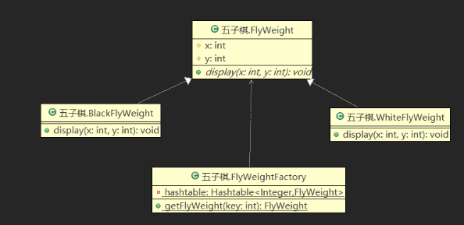
- 说明选择的设计模式？
享元模式：运用共享技术有效地支持大量细粒度对象的复用。
轻量级模式，要求能够被共享的对象必须是细粒度对象
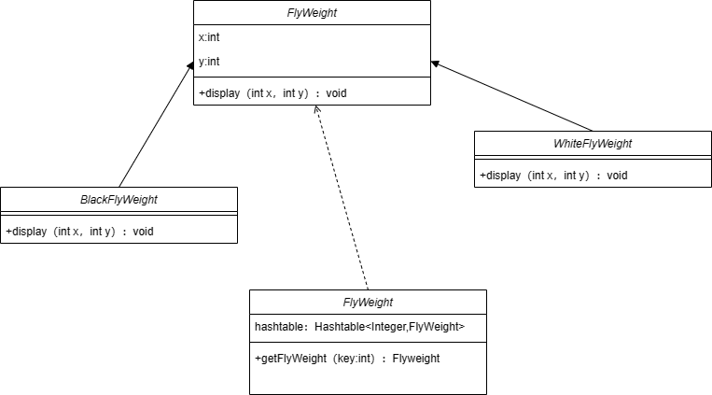

- 编写详细代码。
public abstract class FlyWeight {
protected int x;
protected int y;
public abstract void display(int x,int y);}

public class BlackFlyWeight extends FlyWeight {
@Override
public void display(int x, int y) {
this.x = x;
this.y = y; }
}

public class WhiteFlyWeight extends FlyWeight {
@Override
public void display(int x, int y) {
this.x = x;
this.y = y;

}
}

public class FlyweightFactory {
private Hashtable<String, FlyWeight> flyweights = new Hashtable<String, FlyWeight>();

public FlyWeight getFlyweight(String key) {
if (flyweights.containsKey(key)) {
return flyweights.get(key);
} else {
FlyWeight flyweight = null;
if (key.equals("black")) {
flyweight = new BlackFlyWeight();
} else if (key.equals("white")) {
flyweight = new WhiteFlyWeight();
}
flyweights.put(key, flyweight);
return flyweight;
}
}
}

2.订单系统：一旦订单被创建， 只有订单的创建人才可以修改订单上的数据，其他人则不能修改。三个属性:产品名称、订购数量、订购人。
- 选择代理模式设计。
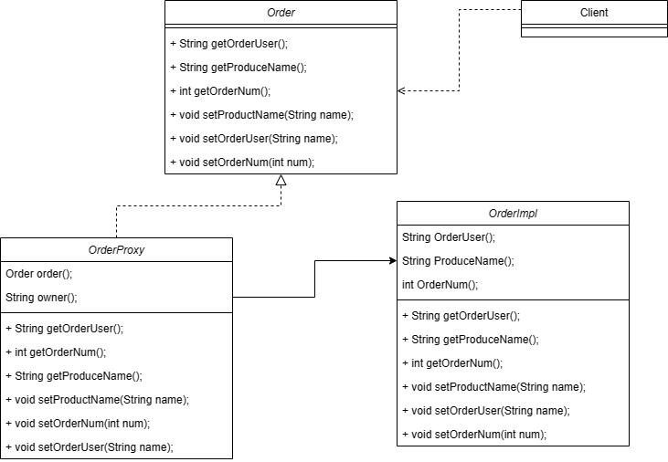
- 编写详细代码。
public interface Order {
String getProductName();
int getOrderNum();
String getOrderUser();
void setProductName(String name);
void setOrderNum(int num);
void setOrderUser(String user);
}

public class OrderImpl implements Order{
private String productName;
private int orderNum;
private String orderUser;

public OrderImpl(String productName, int orderNum, String orderUser) {
this.productName = productName;
this.orderNum = orderNum;
this.orderUser = orderUser;
}

@Override
public String getProductName() {
return productName;
}

@Override
public int getOrderNum() {
return orderNum;
}

@Override
public String getOrderUser() {
return orderUser;
}

@Override
public void setProductName(String name) {
this.productName = name;
}

@Override
public void setOrderNum(int num) {
this.orderNum = num;
}

@Override
public void setOrderUser(String user) {
this.orderUser = user;
}
}

public class OrderProxy implements Order{
private Order order;
private String owner;

public OrderProxy(Order order, String owner) {
this.order = order;
this.owner = owner;
}

@Override
public String getProductName() {
return order.getProductName();
}

@Override
public int getOrderNum() {
return order.getOrderNum();
}

@Override
public String getOrderUser() {
return order.getOrderUser();
}

// 只有创建者可以修改订单数据，其他人没有权限修改
@Override
public void setProductName(String name) {
if (owner.equals(order.getOrderUser())) {
order.setProductName(name);
} else {
throw new UnsupportedOperationException("No authority to modify order data.");
}
}

@Override
public void setOrderNum(int num) {
if (owner.equals(order.getOrderUser())) {
order.setOrderNum(num);
} else {
throw new UnsupportedOperationException("No authority to modify order data.");
}
}

@Override
public void setOrderUser(String user) {
if (owner.equals(order.getOrderUser())) {
order.setOrderUser(user);
} else {
throw new UnsupportedOperationException("No authority to modify order data.");
}
}
}

